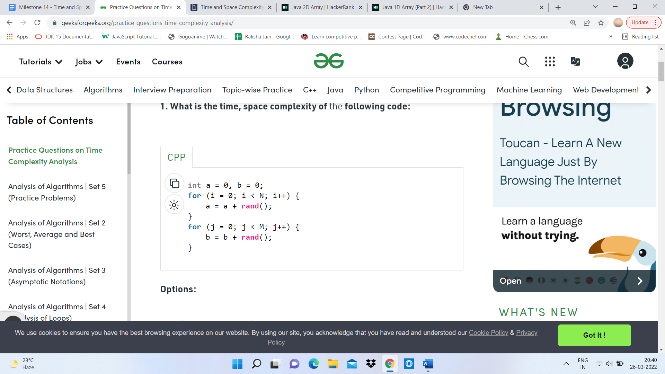

Ans- TIME COMPLEXITY= O(N+M)

SPACE COMPLEXITY= O(1)

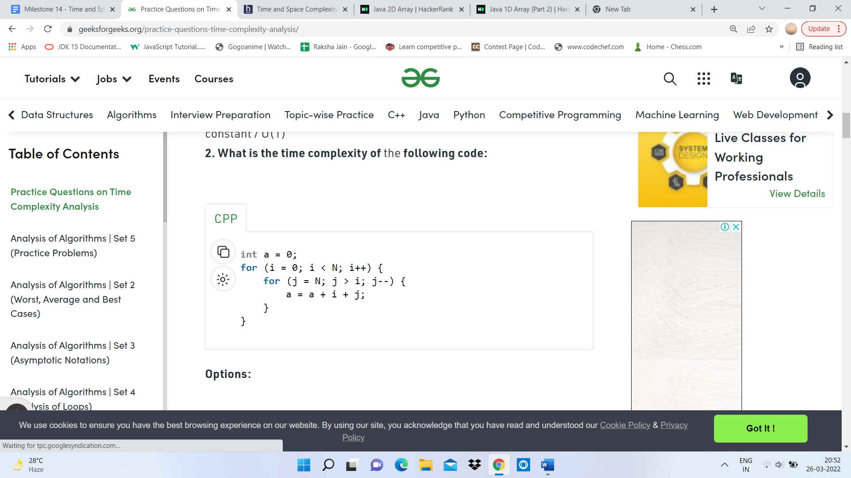

Ans- TIME COMPLEXITY= O(N^2)

SPACE COMPLEXITY= O(1)

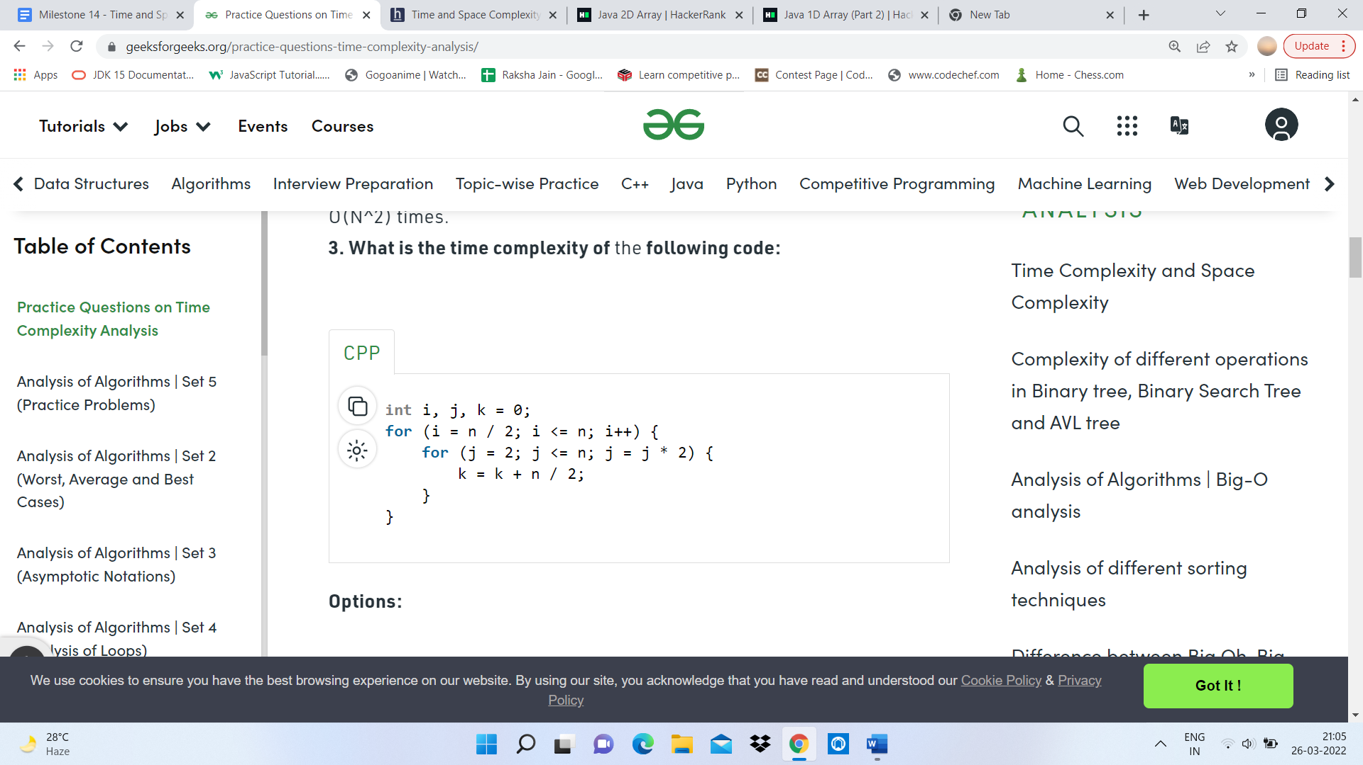

Ans- TIME COMPLEXITY= O(N\*log(N))

SPACE COMPLEXITY= O(1)



Ans- X will always be a better choice for large inputs

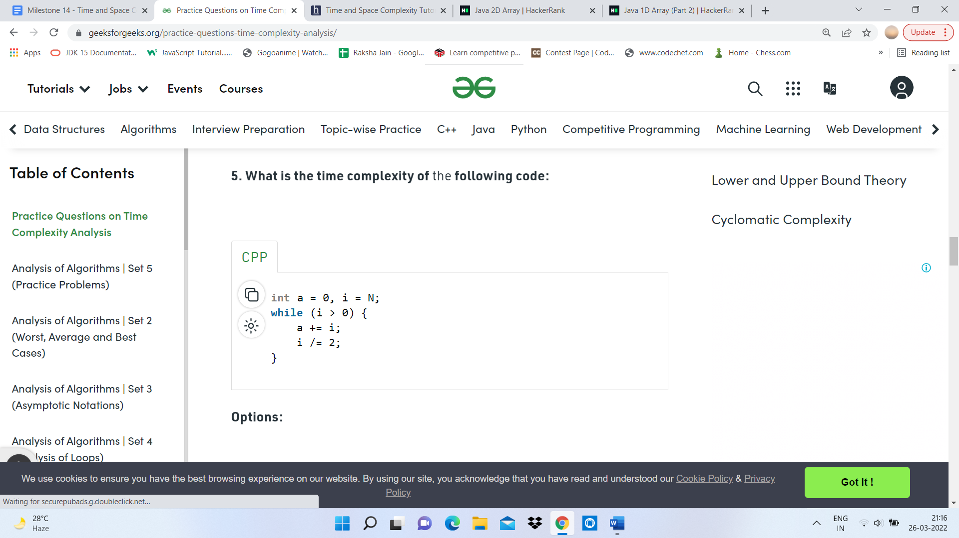

Ans- TIME COMPLEXITY= O(log(N))

SPACE COMPLEXITY= O(1)



Ans- Both of the above



Ans- By counting number of primitive operations performed by algorithm on given input size



Ans- O(logkN)



Ans- O(N\*(N-I)/2)



Ans- False